Table of Contents

Purpose of web frameworks 1

Common Framework Features 1

**CSS**(or Cascading Style Sheets) – It is a language used for styling websites. HTML elements are represented using CSS on a web page. It helps with design, layout, screen sizes etc. It helps beautify a web page. 2

Features used in Website 3

Proposed Web Frameworks 3

Why Angular: 3

Why VueJs: 4

Register, Login, Administer Accounts 4

Angular 4

VueJs 6

Code Snippets 11

Comparing Frameworks 11

Bibliography 12

# 

# Purpose of web frameworks

Web framework is a software framework which is created to support the development of dynamic websites, web applications and web services. The development of a dynamic website is made easy with the use of a web framework. It provides a basic pattern of the code which helps quicken the process of web development. Web frameworks help simplify the process of web development and keep it as modern as possible. Web frameworks automates the repetitive web development tasks. Web frameworks gives you a process for turning an idea into code. A framework is a basic conceptional structure. Most of the applications have a common set of functionalities such as handling session data validation etc, and web framework prevent a developer from re-writing the same code every time to create a web app. The purpose of frame works is to allow developers to build unique features for their web projects instead of rewriting the same code repeatedly. Each framework may provide you a wide range of web app functionalities, resulting in a less error-prone program. In a nutshell, a framework aids in the prototyping, design, and implementation phases of the app development lifecycle, as well as the continuing maintenance and enhancement of a web application. Frameworks are very helpful when it comes to online security. Coming up with your own security is costly and dangerous if you do not do it right. To make anything more resilient, a framework can incorporate security aspects into its functioning and combine bug-fixing efforts. A framework can be secure by default, at least in theory. Most applications/websites these days require login, signup, password rest, authorization, API’s, logging, database, sending emails, payment processing, deployment, input validation etc, if a beginner must implement all of this in their design without a framework, they would be lost, but with the help of a framework these tasks can be implemented easily and can be reused if possible.

There are two types of Frameworks Client side(frontend) and Server(Backend) side frameworks

Server side – These control the database, the logic of the application, payment methods, security of the website and the server configurations. Some of the common server side frameworks are, expressjs, ruby on rails, Laravel, Django etc

Client side – Everything that you see on the website in the UI is controlled using the client side frameworks. Some of the common client side frameworks are, vue.js, angular, react etc.

## Common Framework Features

Some of the common features in a web framework are:-

**Caching –** Web caching helps save documents while reducing bandwidth consumption., server load and perceived lag. A web caches stores copies of pages that travel through it and if certain requirements are met, the following request can be served from the cache. Some application frameworks have features for caching documents and skipping certain stages of page preparation such as database authentication. (Web)

**Security –** Most frameworks these days come with authentication and authorization, which helps with the login, register etc of a web application, this helps restrict access to users which don’t meet the defined criteria. Security in a system allows users to view pages based on their roles and has a web-based interface for establishing users and assigning them roles. (Web)

**Database access, mapping and configuration -** Many web frameworks provide a single API to a database backend, allowing web applications to interact with a range of databases with no code modifications and programmers to focus on higher-level concepts. (Web)

**URL Mapping -** The process through which a framework reads URLs is known as URL mapping or routing. Shorter, more "friendly URLs" can be used with a URL mapping system that employs pattern matching or rewriting to route and manage requests, boosting the site's simplicity and allowing for easier indexing by search engines.

**AJAX (“Asynchronous JavaScript and XML”) –** Is a technique which is used for creating web applications. The goal is to make web pages feel more responsive by exchanging little pieces of data with the server behind the scenes, rather than reloading the complete page every time the user demands a change. This is done to improve the interactivity, speed, and usability of a web page.

**Web Services -** Some frameworks include web service creation and provisioning features. These tools may be comparable to those found in the rest of the web application.

**HTML** **(or Hypertext Markup Language) -**  It is a computer language used to build websites.

**CSS (or Cascading Style Sheets)** – It is a language used for styling websites. HTML elements are represented using CSS on a web page. It helps with design, layout, screen sizes etc. It helps beautify a web page.

**Components –** Web Component-based custom components and widgets will function in all modern browsers and may be used with any JavaScript library or framework that works with HTML.

## Features used in Website

The features which are used in the project are URL Mapping, the URL routing is more user friendly. So, the users can easily tell what page they’re on instead of reading through some complicated routes. We have also used the security feature on the website, we have used JWT authorization to always keep the user accounts secure. We also have different login accounts of different users, e.g., the content visible to an admin user is restricted to an admin account, whereas the user account will only have access to the content we want visible for regular users. Hence the security on the website has been given priority. We have also used Database access, mapping, and configuration, we have used MongoDb to store our database. We also have the feature of web service on the website since we do have a server running on our computer, listening to port over a network, serving our web documents. (htt21). For the front end we have used components (Material components). These are interactive building blocks for creating a user interface. Angular has a proper documentation which explains well how to use these components on the website. Everything you see in the UI is made up of different components.

# Proposed Web Frameworks

The two frameworks we recommend for this project are Angular and VueJs.

## Why Angular:

Because it eliminates the need for extraneous code, Angular ensures that development is simple. It has an MVC architecture that eliminates the need to write getters and setters. Because directives are not part of the app code, they can be controlled by another team. Developers can expect less coding and lighter, faster apps in general.

## Why VueJs:

Vue.js is a JavaScript progressive framework for building web interfaces and one-page applications. Vue.js is utilized not only for online interfaces, but also for desktop and mobile app development utilizing the Electron framework.

# Register, Login, Administer Accounts

## Angular

Below is the screenshot of the Sign Up Page using Angular - <http://localhost:4200/signup>

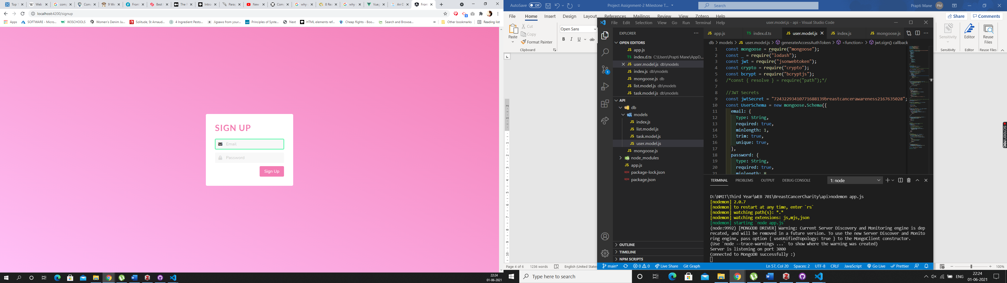

If you inspect the page after putting in your details and clicking the sign up button, you will see in the console that you get a “successfully signed up and logged in” message. Below is the screenshot showing that information

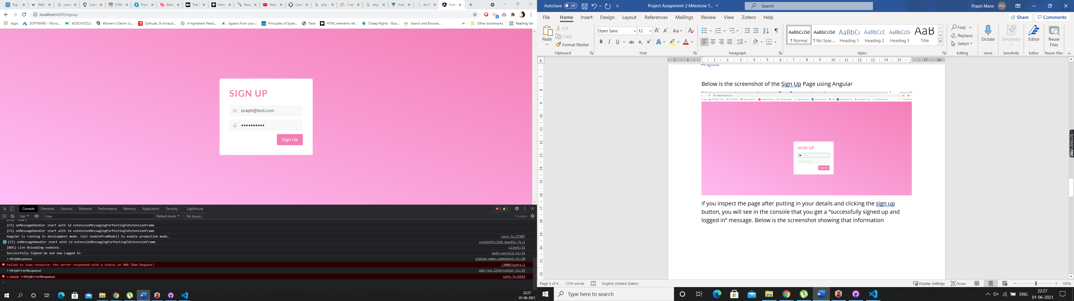

Below is the screenshot of the login page - <http://localhost:4200/login>

We logged in using – [prapti@test.com](mailto:prapti@test.com) password – helloworld

Once you inspect the page and check the console you should be able to see the “logged in” message with the status as 200 and true. Which means the user has successfully logged into the app.

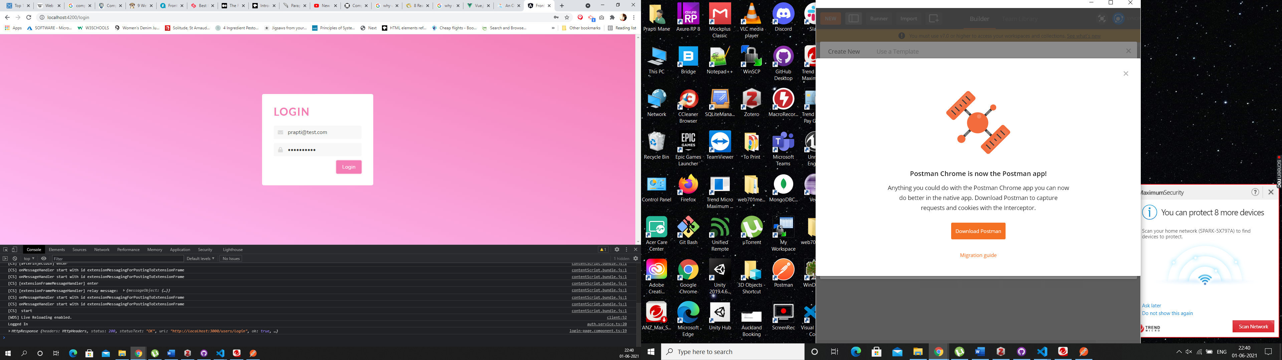

At this stage for Angular we do not have different login’s set up, but for the final product we will have different login and content for Admin, Moderator and User, we do have a working example of that in VueJs which we will show you next.

## VueJs

Below is the main screen which will consist of the public content of the website, which is general content, so any information about the charity etc and content that is not targeted towards certain users only will be on this page. This will be the Homepage of the website. We just have the skeleton of the website at this stage for demo purpose.

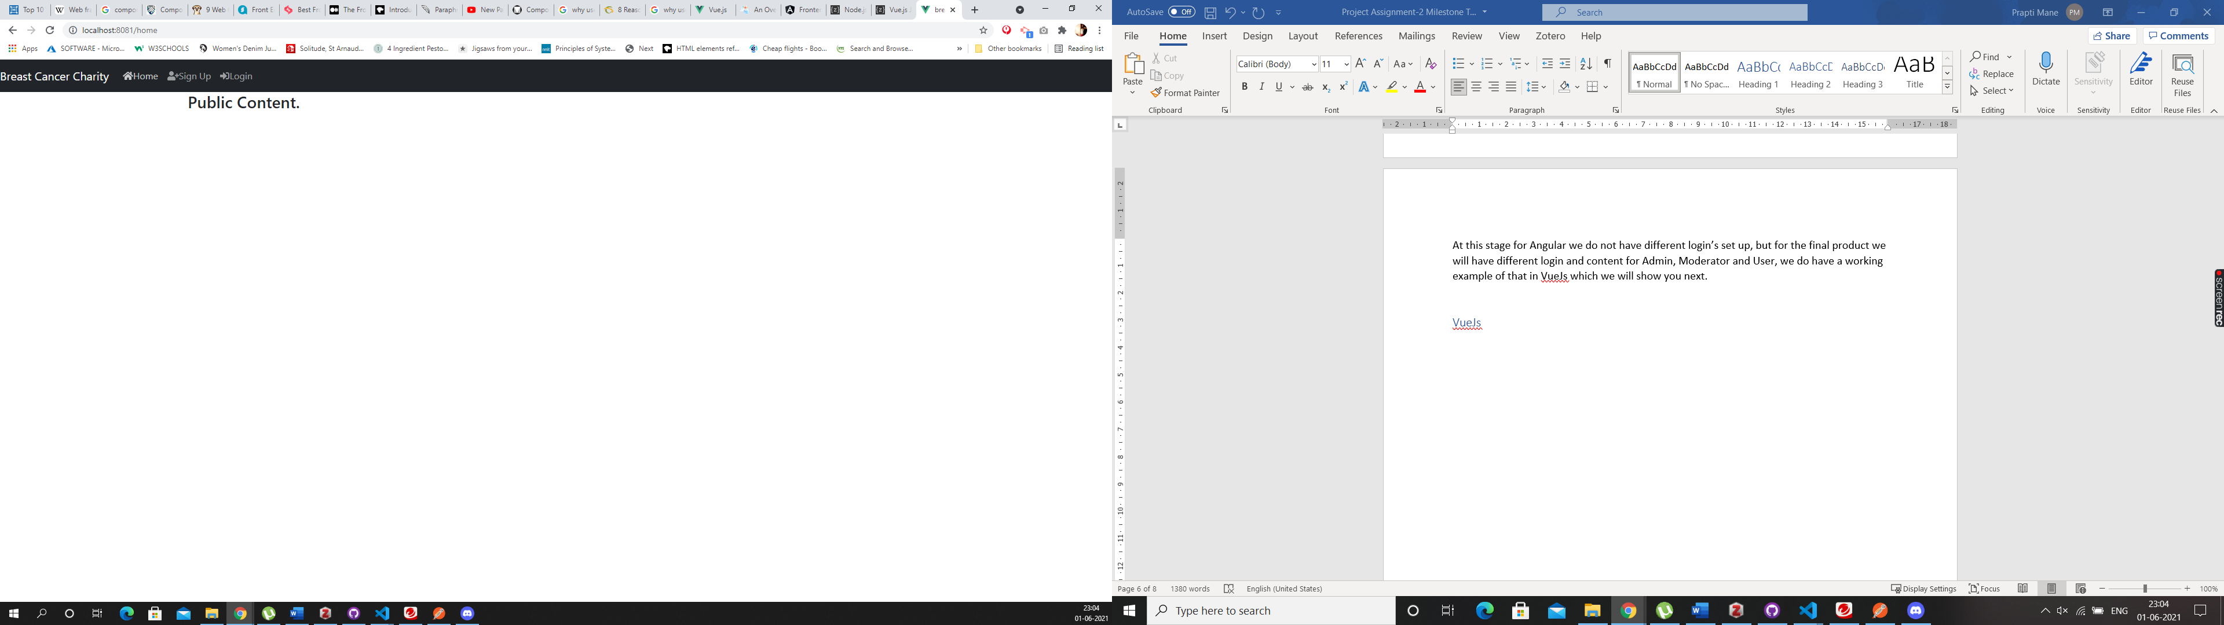

Click on the Sign Up in the navigation bar and it will direct you to this page - <http://localhost:8081/register>

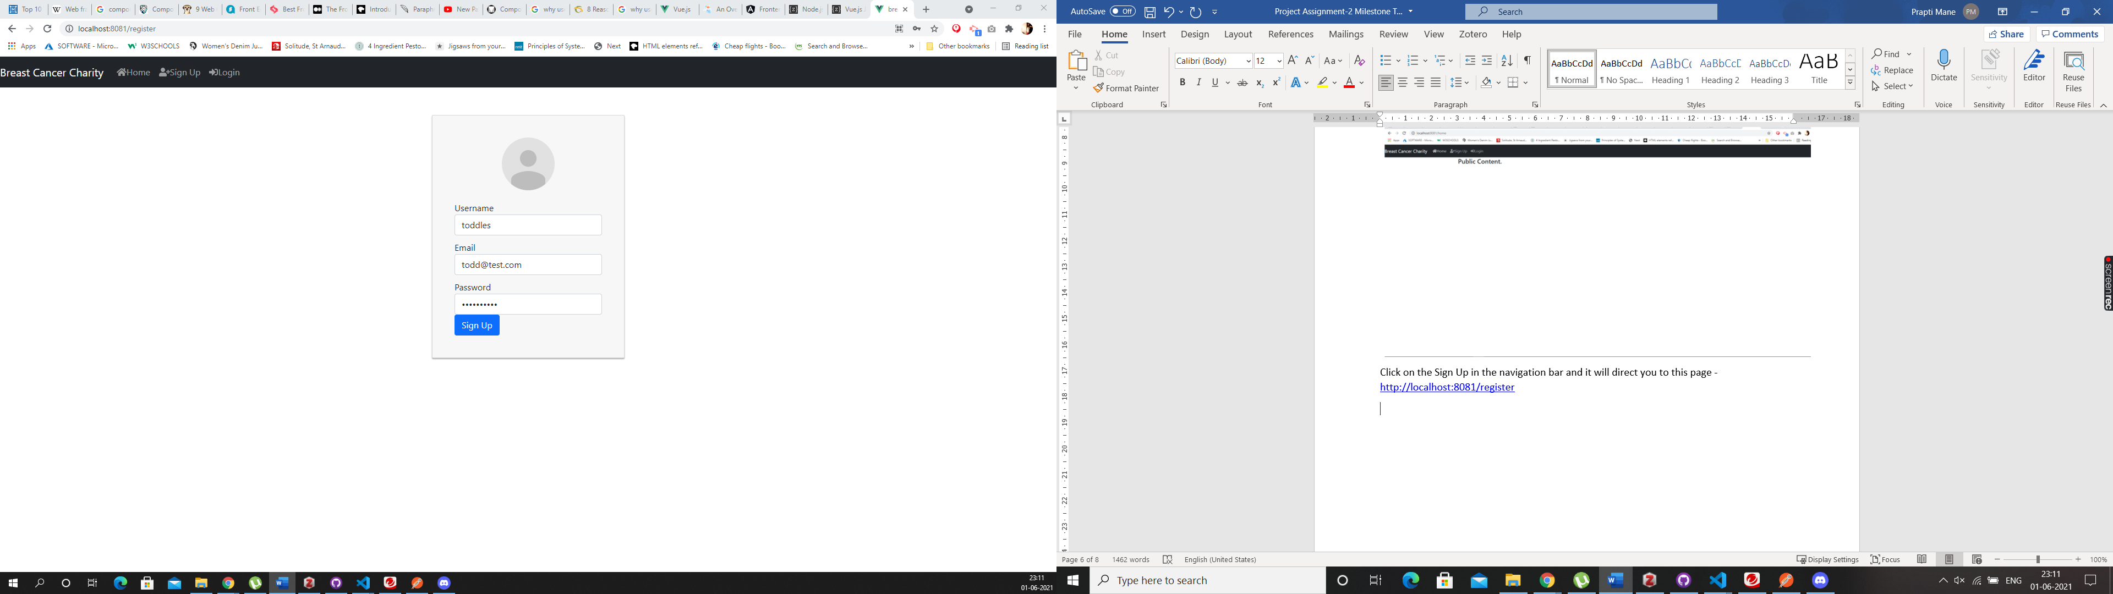

Enter you details as shown in the above picture and then press the “Sign Up” button. Once you register you will be shown the below screen

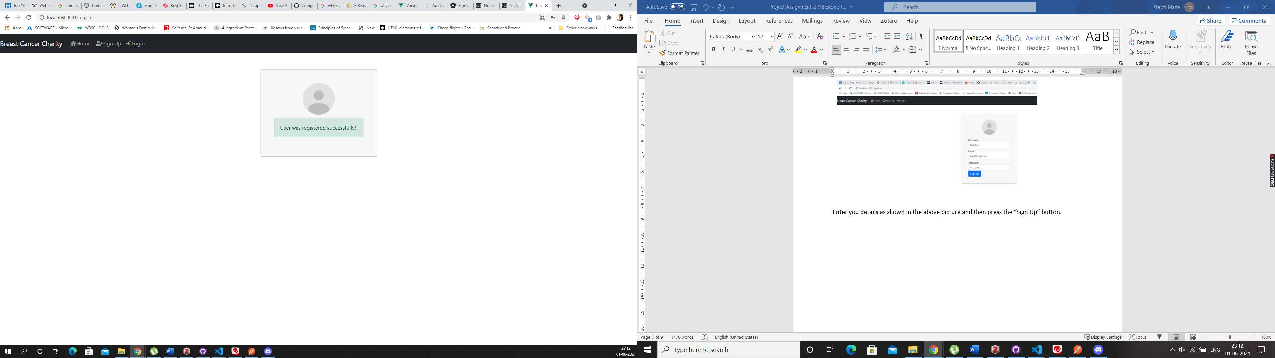

Then go to the Navigation bar and click on the Login button, you will be directed to the below screen : <http://localhost:8081/login>

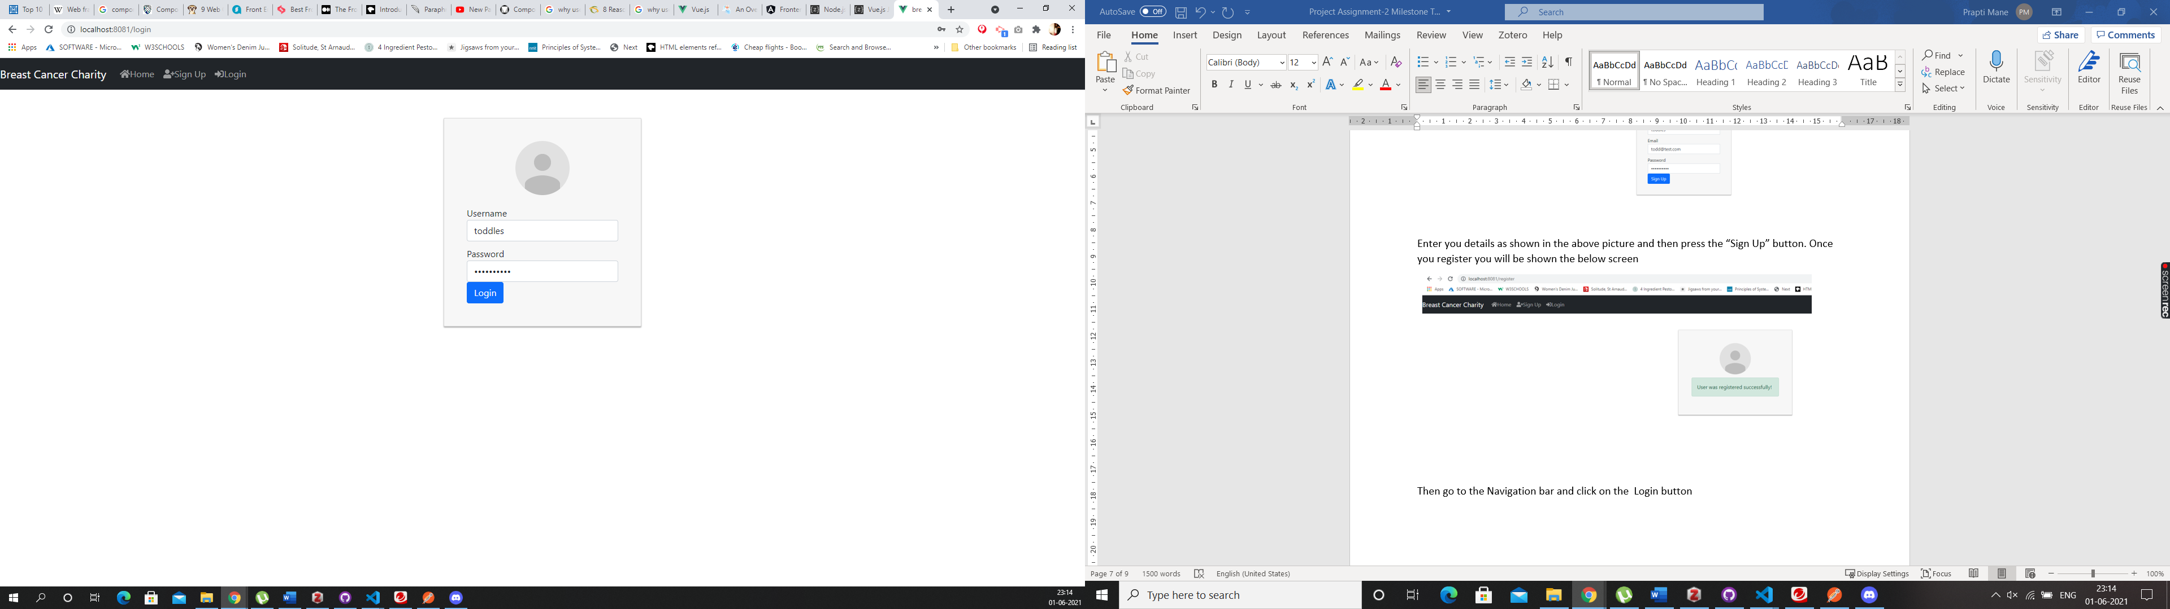

Enter your details and click on the “Login” button, which will take you to the below screen, which is the Profile screen - <http://localhost:8081/profile>

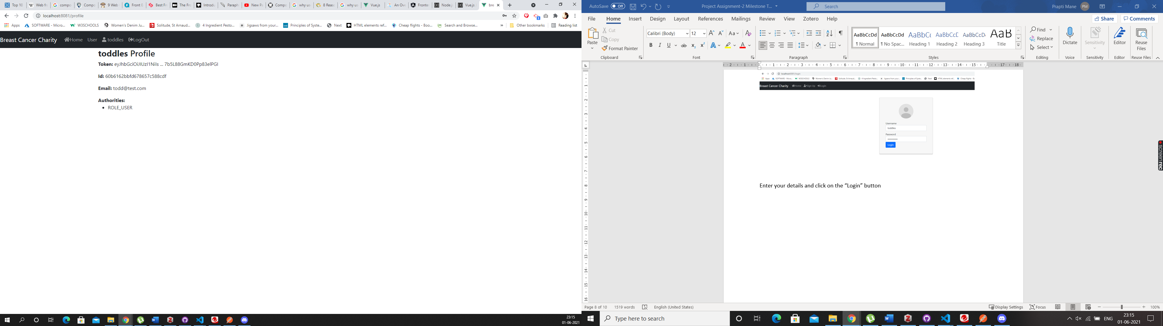

As you can see in the above image, the profile that we have created is for that of a User, so when a regular user goes onto the website and register themselves, they only have access to the content that is created just for the user’s. If you click on “User” in the navigation bar it will direct, you to the below screen. <http://localhost:8081/user>

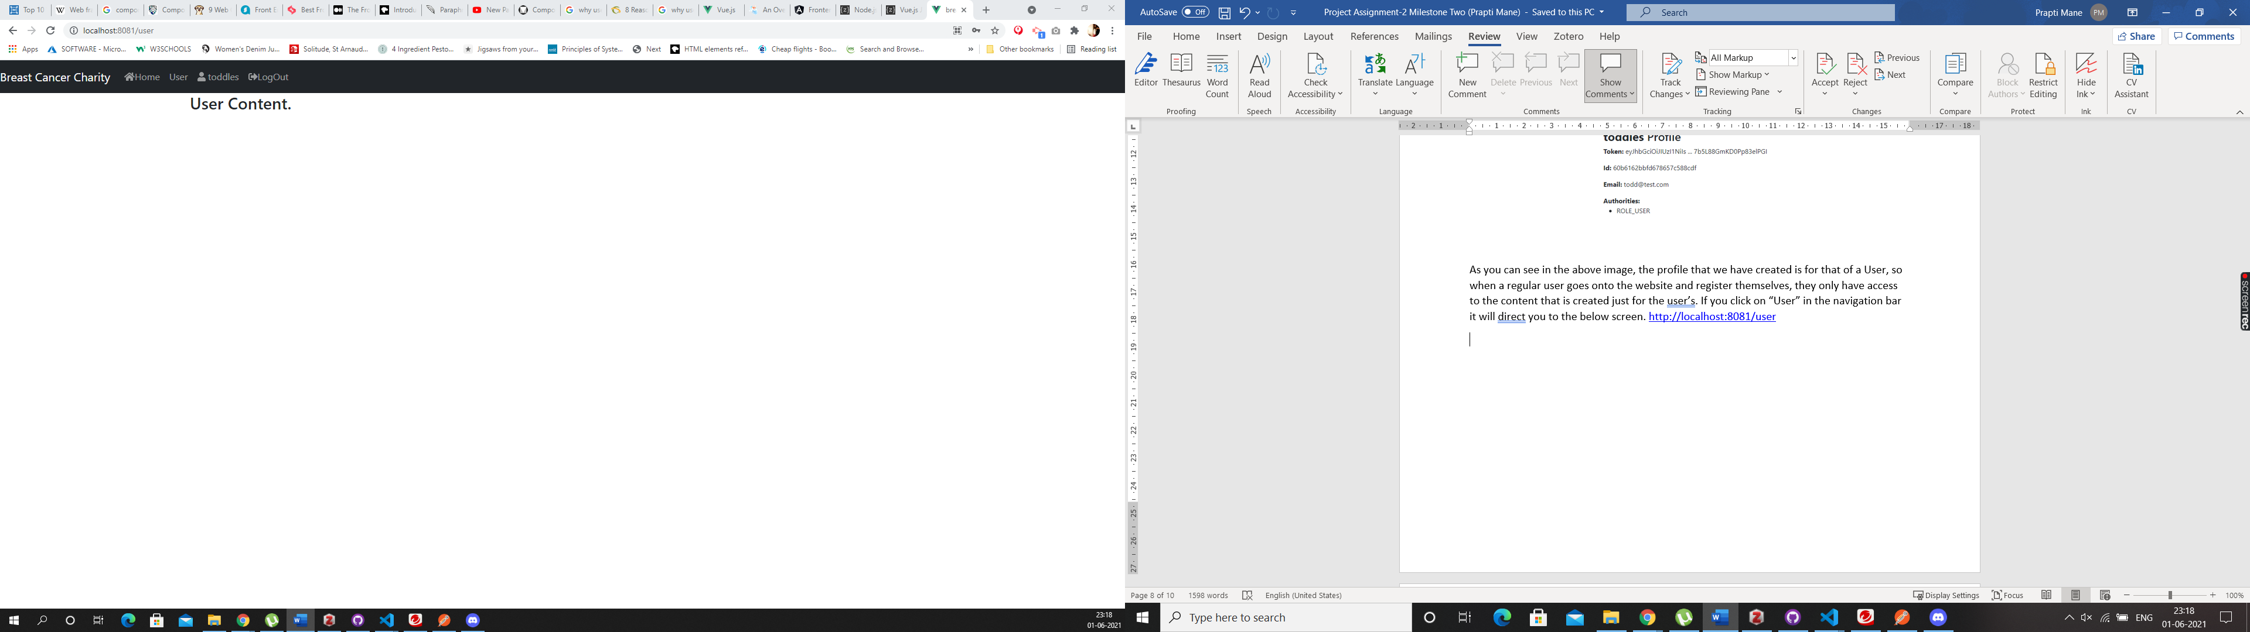

As you can clearly see that the content that the content on this page is specifically designed for the users.

If you want to create a Moderator or Admin account, it can be done through the backend. I have created an Admin account using Postman for this website. I am going to login into that account and show you the difference between the two. As you can see there is no way a user can register as an Administrator unless they do it through the backend, which is a good option as you do not want everyone to have access to the admin account.

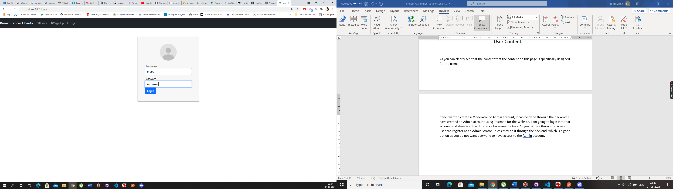

In the above screen as you can see I am going to login as “Prapti” since I have already created an Admin account for me. Once you click the “login” button you will be directed to the below screen

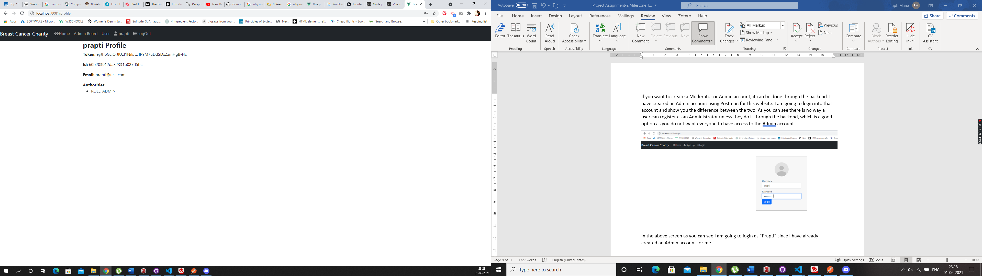

As you can see once logged in as an Administrator, I have access to the admin board, which you cannot see from the user account, but I also have access to the “user account” content. As an admin I can access anything on the website but a regular has access to limited content on the website, they will only see what we show them.

We also have a third type of account on the website which is a moderator account. I have logged in using “kayla” account who is the moderator for the website, but also have access to the user account. Below is a screenshot of the dashboard for a moderator account.

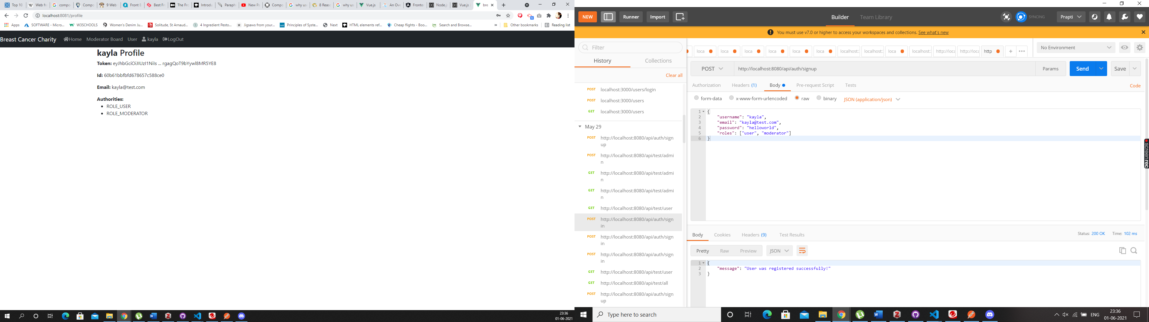

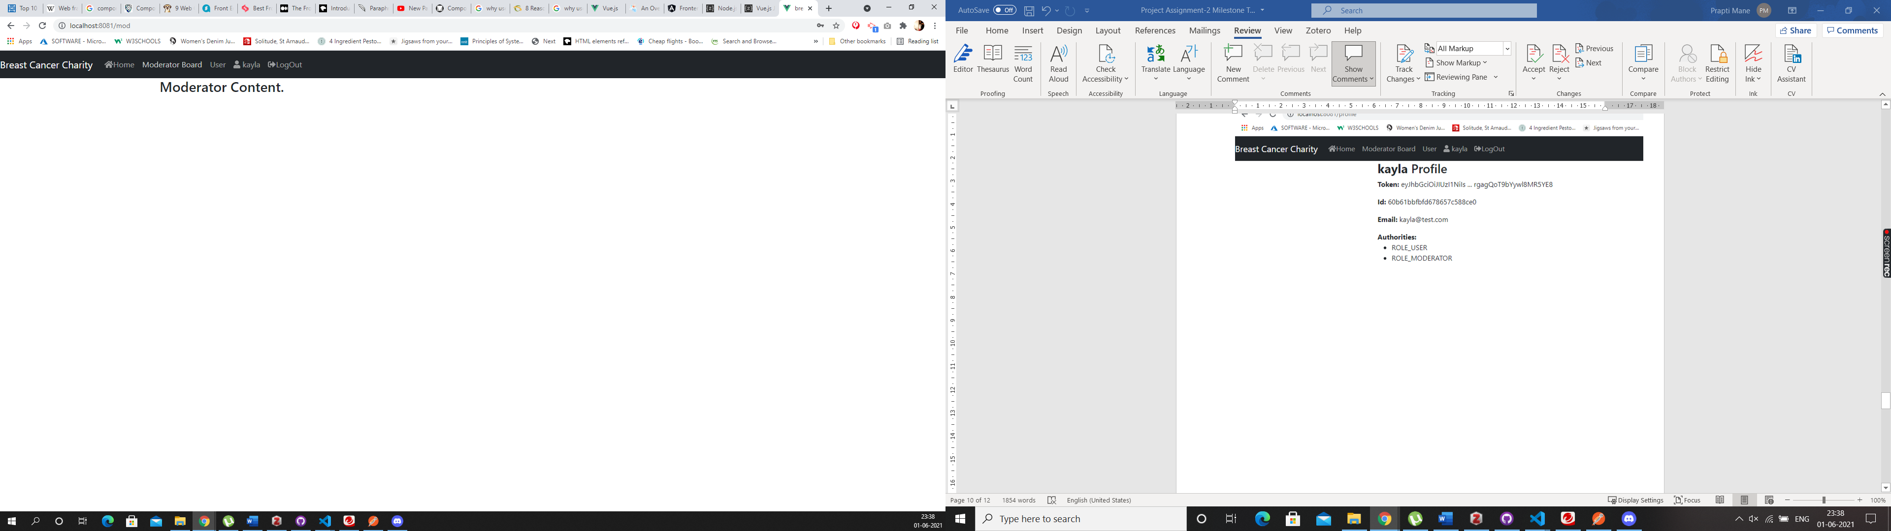

As you can see Kayla’s account has access to the Moderator content and the user content but not the Admin content. These roles can be changed using the backend/ postman.

## Code Snippets

VueJs – User Model Angular – User Model

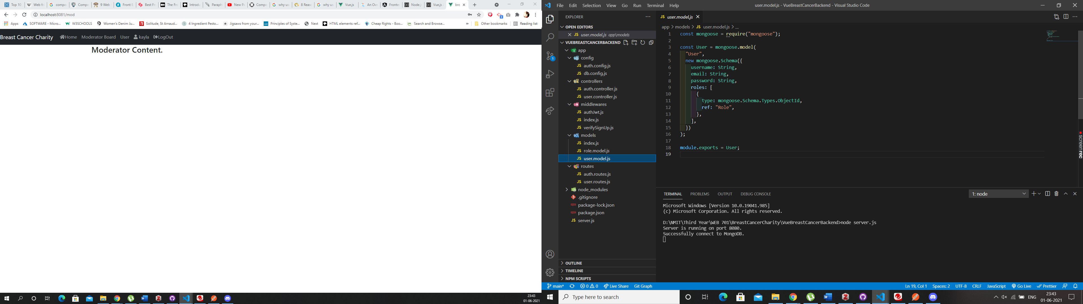 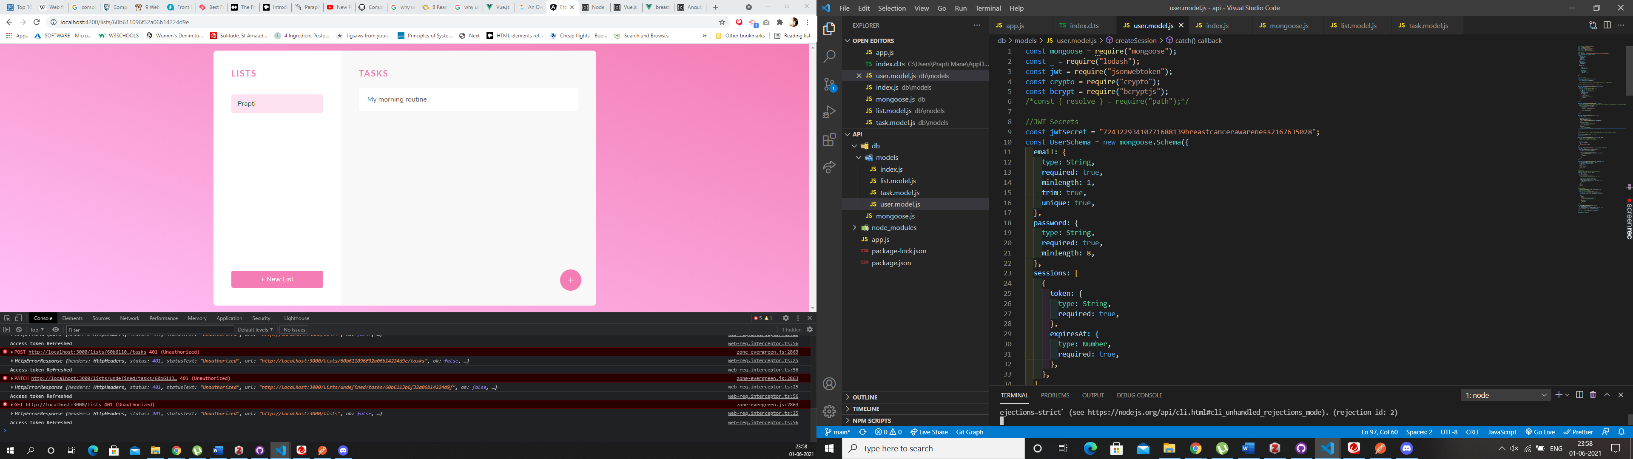

The code in VueJs is pretty straight forward, whereas in Angular in User Model most of the methods are especially including the refreshing of JWT tokens it is all set up in the User Model making the code far more complicated to read. Although this can be sorted if we create a separate model in angular which will deal with the Access tokens this issue can be sorted. The helper methods everything is in the UserModel in angular at this stage. This code could’ve been written better by segragating it.

The code in VueJs is simple and not at all complicated, it shows exactly how the UserModel is using Mongoose and what values are needed for a user. This is how the data will be collected in MongoDb database. It is easier to understand that the User object will have a roles array that contains ids in roles collection as a reference.

## Comparing Frameworks – Registration and Login

When it came to coding the registration and the sign-up part of the website, I did find the VueJs framework to be easier than Angular. Although both the websites do have similar patterns, certain parts in Angular are much more complicated than VueJs, as mentioned online VueJs initially was inspired by Angular, and any complicated parts of Angular were made simpler in VueJs hence the code also looks similar but is much more complicated in Angular. The security side of things when it comes to login and registration felt the same, although applying JWT felt a bit more complicated in Angular as it did in view, and as you can see in View it was easier to accomplish the exact login functionality as per the requirement whereas in Angular so far we have only been able to login as a regular user with no defined roles. One of the major drawbacks I found in Angular is that Typescript is mandatory. Vue is more flexible when it comes to that.

Angular deals with Modules whereas Vue is about Components. Angular is all about MVC, which we have worked with in react in the past, so understanding it was slightly easier.

# Bibliography

What is a Web Framework? (2017, July 28). *GoodFirms Glossary - GoodFirms*. <https://www.goodfirms.co/glossary/web-framework/>

*What is a web framework? | CodingNomads*. (n.d.). Retrieved May 30, 2021, from <https://codingnomads.co/blog/what-is-a-web-framework/>

*Why do we use Web Frameworks?* (2017, June 19). LispCast. <https://lispcast.com/why-web-frameworks/>

*How useful are web application frameworks? & How do I know which framework would suit me?* (2014, September 23). Cuelogic Technologies Pvt. Ltd. <https://www.cuelogic.com/blog/how-useful-are-web-application-frameworks-how-do-i-know-which-framework-would-suit-me>

Web framework. (2021). In *Wikipedia*. <https://en.wikipedia.org/w/index.php?title=Web_framework&oldid=1022782175>

Web service. (2021). In *Wikipedia*. <https://en.wikipedia.org/w/index.php?title=Web_service&oldid=1021433007>

*8 Proven Reasons You Need Angular for Your Next Development Project*. (n.d.). Grazitti Interactive. Retrieved June 1, 2021, from <https://www.grazitti.com/blog/8-proven-reasons-you-need-angular-for-your-next-development-project>

The Good and the Bad of Vue.js Framework Programming. (n.d.). *AltexSoft*. Retrieved June 1, 2021, from <https://www.altexsoft.com/blog/engineering/pros-and-cons-of-vue-js/>